**ОПИСАНИЕ**

Проект реализован на базе движка Unity 2022 (язык C#).

Данный проект по автогенерации датасета построен на основе взаимодействия трех различных уровней классов. На верхнем уровне существует некоторый глобальный управляющий элемент **GlobalController** – при старте он в автоматическом режиме последовательно через интерфейсы (**ITransformable**, **IRaycastable** и **IScreenshotable**) вызывает методы реализующих эти интерфейсы классов (**ObjectTransformer, RaycastGenerator** и **ScreenshotMaker**). Количество таких последовательных вызовов ограничено рядом факторов.

Интерфейсы являются промежуточным уровнем между глобальным управлением и реализацией. Они же связывают ручное управление (которое представлено классами (**InputObject** и **InputScreenshotCamera**) с той же реализацией. Ручное управление является важным инструментом отладки (проверки выполнения граничных значений, корректного выполнения кода, успешного сохранения данных и др.).

Классы **ObjectTransformer, RaycastGenerator** и **ScreenshotMaker**, являющиеся реализацией соответствующих интерфейсов, представляют из себя последовательный цикл: **ObjectTransformer** – трансформация объекта (его перемещение в специально отведенном для него пространстве на сцене, вращение объекта, его масштабирование и замена исследуемого объекта на следующий по списку после полного прохождения цикла «перемещение-вращение-масштабирование»); **RaycastGenerator** – запуск лучей, с помощью которых определяется расстояние от плоскости до поверхности объекта; **ScreenshotMaker** – получение изображение объекта с нужного ракурса и сохранение в требуемом формате с уникальным именем.

Пользователю доступны гибкие инструменты регулирования процессом автогенерации:

1. Изменение значений объекта:
   1. шаг перемещения на сцене;
   2. значение угла поворота;
   3. шаг масштабирования.
2. Добавление новых объектов к имеющемуся списку;
3. Управление количеством лучей, испускаемых от плоскостей;
4. Изменение времени итерации глобального управления;

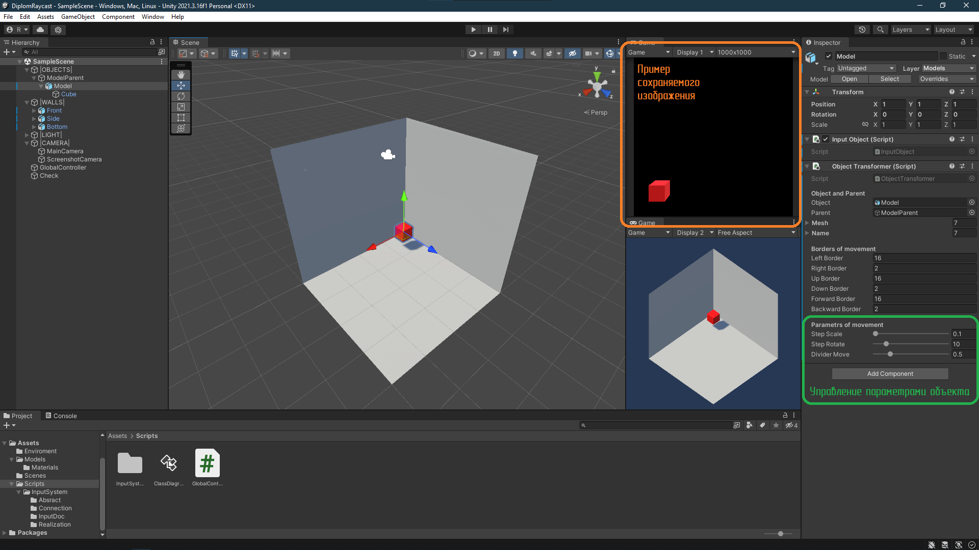

Рис. 1 Интерфейс Unity

Пример одной итерации:

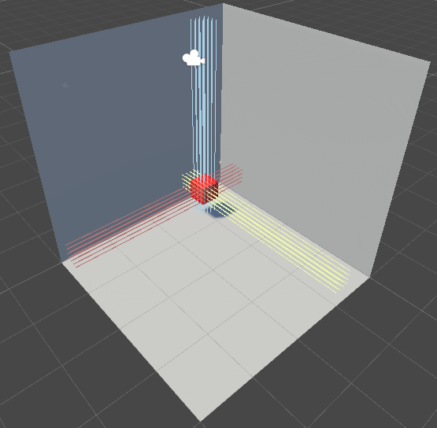

Рис. 2. Пример работы

Объект (куб) был перемещен на установленный шаг, от плоскостей до объекта было пущено заданное количество лучей (эти данные были записаны в файл .txt – см. рис.3), после чего было сохранено изображение объекта (см. рис.4).

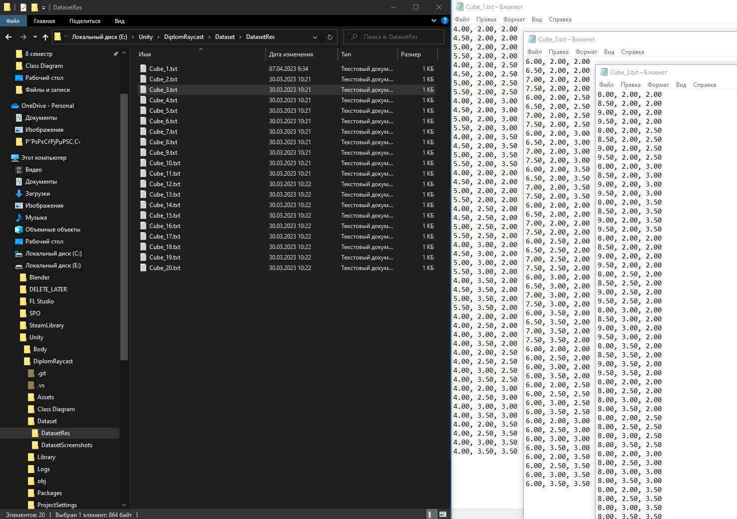

Рис. 3. Записанные данные

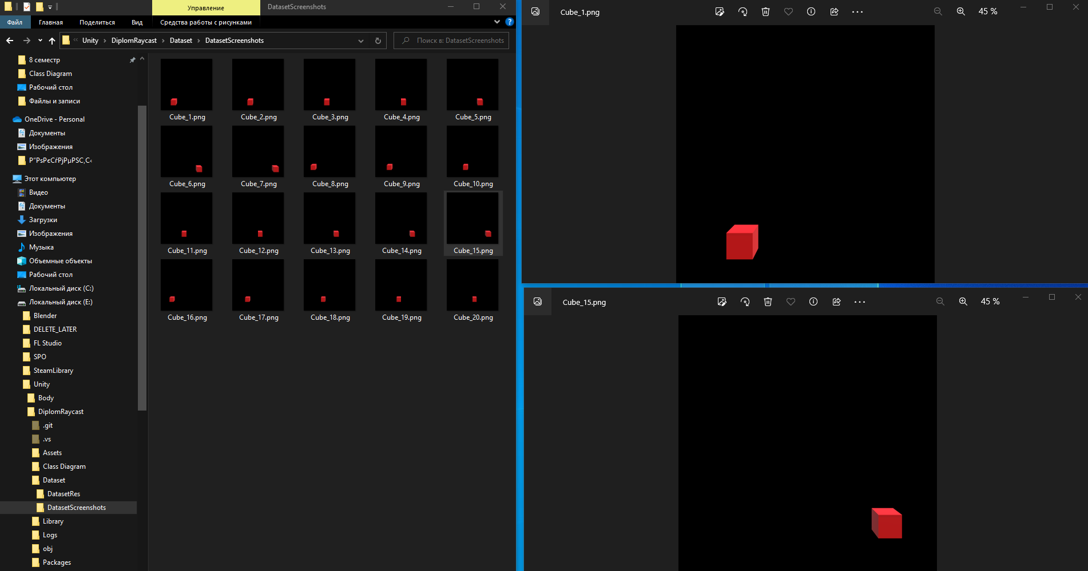

Рис. 4. Изображения

**АБСТРАКЦИЯ (ИНТЕРФЕЙСЫ)**

**ITransformable**

using UnityEngine;

public interface ITransformable

{

void ManualInputMove(Vector3 inputDirection);

void AutomaticMove();

Vector3 GetCurrentModelPosition();

Vector3 GetModelSize();

string GetModelName();

int GetTransformIteration();

}

**IRaycastable**

using System.Collections.Generic;

using UnityEngine;

public interface IRaycastable

{

void ManualInputRaycast();

List<Vector3> AutomaticRaycast(Vector3 startPosition, Vector3 area);

}

**IScreenshotable**

public interface IScreenshotable

{

void ManualInputScreenshot();

void AutomaticScreenshot();

void AutomaticScreenshot(string _name, int number);

}

**СВЯЗЬ**

**InputObject**

using System;

using UnityEngine;

using UnityEngine.InputSystem;

public class InputObject : MonoBehaviour

{

private InputDoc _inputDoc;

private ITransformable _movable;

private void Awake()

{

if (_inputDoc == null)

{

_inputDoc = new InputDoc();

}

_movable = GetComponent<ITransformable>();

if (_movable == null)

{

throw new Exception($"There is no IMovable on the object: {gameObject.name}");

}

}

private void OnEnable()

{

_inputDoc.Enable();

_inputDoc.Management.Move.performed += OnMovePerfermed;

}

private void OnMovePerfermed(InputAction.CallbackContext obj)

{

var inputDirection = _inputDoc.Management.Move.ReadValue<Vector3>();

_movable.ManualInputMove(inputDirection);

}

private void OnDisable()

{

_inputDoc.Disable();

_inputDoc.Management.Move.performed -= OnMovePerfermed;

}

}

**InputScreenshotCamera**

using System;

using UnityEngine;

using UnityEngine.InputSystem;

public class InputScreenshotCamera : MonoBehaviour

{

private InputDoc _inputDoc;

private IScreenshotable _screenshotable;

private void Awake()

{

if (_inputDoc == null)

{

_inputDoc = new InputDoc();

}

_screenshotable = GetComponent<IScreenshotable>();

if (_screenshotable == null)

{

throw new Exception($"There is no IJumpable on the object: {gameObject.name}");

}

}

private void OnEnable()

{

_inputDoc.Enable();

_inputDoc.Management.Screenshot.performed += OnScreenshotPerfermed;

}

private void OnScreenshotPerfermed(InputAction.CallbackContext obj)

{

_screenshotable.ManualInputScreenshot();

}

private void OnDisable()

{

_inputDoc.Management.Screenshot.performed -= OnScreenshotPerfermed;

_inputDoc.Disable();

}

}

**РЕАЛИЗАЦИЯ**

**ObjectTransformer**

using UnityEngine;

public class ObjectTransformer : MonoBehaviour, ITransformable

{

#region Parametrs in Inspector

[Header("Object and Parent")]

[SerializeField] private GameObject _object;

[SerializeField] private GameObject _parent;

[SerializeField] private Mesh[] _mesh;

[SerializeField] private string[] _name;

[Space(2)]

[Header("Borders of movement")]

[SerializeField] private float _leftBorder;

[SerializeField] private float _rightBorder;

[SerializeField] private float _upBorder;

[SerializeField] private float _downBorder;

[SerializeField] private float _forwardBorder;

[SerializeField] private float _backwardBorder;

[Space(2)]

[Header("Parametrs of movement")]

[SerializeField][Range(0.1f, 1.0f)] private float _stepScale;

[SerializeField][Range(1, 60)] private byte _stepRotate;

[SerializeField][Range(0.1f, 2.0f)] private float _dividerMove;

#endregion

private Vector3 _inputDirection;

private Vector3 _startPosition;

private Quaternion _startRotation;

private Vector3 _startScale;

private Vector3 _stepPosition;

private Vector3 _angleRotation;

private Vector3 _factorScale;

private byte _bitCounterRotation;

private byte _bitCounterScale;

private byte _maxBitCounter;

private byte _xBitMask;

private byte _yBitMask;

private byte _zBitMask;

private byte _numberOfMesh;

private int _transformIteration;

private void Awake()

{

_inputDirection = Vector3.one;

_startPosition = _parent.transform.position;

_startRotation = _object.transform.rotation;

_startScale = _parent.transform.localScale;

_stepPosition = _startPosition;

_angleRotation = Vector3.zero;

_factorScale = Vector3.zero;

_bitCounterRotation = 1;

_bitCounterScale = 1;

_maxBitCounter = 8;

_xBitMask = 1;

_yBitMask = 2;

_zBitMask = 4;

_numberOfMesh = 1;

_transformIteration = 0;

}

public void ManualInputMove(Vector3 inputDirection)

{

_stepPosition.x = (float)System.Math.Round(_stepPosition.x + inputDirection.x / _dividerMove, 1);

if (_stepPosition.x > _leftBorder)

_stepPosition.x = _rightBorder;

else if (_stepPosition.x < _rightBorder)

_stepPosition.x = _leftBorder;

_stepPosition.y = (float)System.Math.Round(_stepPosition.y + inputDirection.y / _dividerMove, 1);

if (_stepPosition.y < _downBorder)

_stepPosition.y = _upBorder;

else if (_stepPosition.y > _upBorder)

_stepPosition.y = _downBorder;

_stepPosition.z = (float)System.Math.Round(_stepPosition.z + inputDirection.z / _dividerMove, 1);

if (_stepPosition.z < _backwardBorder)

_stepPosition.z = _forwardBorder;

else if (_stepPosition.z > _forwardBorder)

_stepPosition.z = _backwardBorder;

_object.transform.position = _stepPosition;

Debug.Log("Object moved (Manual Input)");

}

public void AutomaticMove()

{

_transformIteration++;

_stepPosition.x = (float)System.Math.Round(_stepPosition.x + _inputDirection.x / _dividerMove, 1);

if (_stepPosition.x > _leftBorder)

{

_stepPosition.x = _rightBorder;

_stepPosition.z = (float)System.Math.Round(_stepPosition.z + _inputDirection.z / _dividerMove, 1);

if (_stepPosition.z > _forwardBorder)

{

_stepPosition.z = _backwardBorder;

_stepPosition.y = (float)System.Math.Round(_stepPosition.y + _inputDirection.y / _dividerMove, 1);

if (_stepPosition.y > _upBorder)

{

_stepPosition = _startPosition;

AutomaticRotate();

if (_bitCounterRotation >= _maxBitCounter)

{

AutomaticScale();

_bitCounterRotation = 1;

if (_bitCounterScale >= _maxBitCounter)

{

_bitCounterScale = 1;

_transformIteration = 0;

_object.GetComponentInChildren<MeshFilter>().mesh = _mesh[_numberOfMesh % _mesh.Length];

_object.GetComponentInChildren<MeshCollider>().sharedMesh = _mesh[_numberOfMesh % _mesh.Length];

_object.transform.GetChild(0).name = _name[_numberOfMesh++ % _name.Length];

}

}

}

}

}

_parent.transform.position = _stepPosition;

}

private void AutomaticRotate()

{

if ((_bitCounterRotation & _xBitMask) == _xBitMask)

_angleRotation.x += _stepRotate;

if ((_bitCounterRotation & _yBitMask) == _yBitMask)

_angleRotation.y += _stepRotate;

if ((_bitCounterRotation & _zBitMask) == _zBitMask)

_angleRotation.z += _stepRotate;

if (_angleRotation.x <= 360 && _angleRotation.y <= 360 && _angleRotation.z <= 360)

_object.transform.rotation = _startRotation * Quaternion.Euler(_angleRotation);

else

{

_angleRotation = Vector3.zero;

_bitCounterRotation++;

}

}

private void AutomaticScale()

{

if ((_bitCounterScale & _xBitMask) == _xBitMask)

_factorScale.x = (float)System.Math.Round(_factorScale.x + _stepScale, 1);

if ((_bitCounterScale & _yBitMask) == _yBitMask)

_factorScale.y = (float)System.Math.Round(_factorScale.y + _stepScale, 1);

if ((_bitCounterScale & _zBitMask) == _zBitMask)

_factorScale.z = (float)System.Math.Round(_factorScale.z + _stepScale, 1);

if (_factorScale.x <= 5 && _factorScale.y <= 5 && _factorScale.z <= 5)

_parent.transform.localScale = _startScale + _factorScale;

else

{

_parent.transform.localScale = _startScale;

_factorScale = Vector3.zero;

_bitCounterScale++;

}

}

public Vector3 GetCurrentModelPosition()

{

return gameObject.GetComponentInChildren<Renderer>().bounds.min;

}

public Vector3 GetModelSize()

{

return gameObject.GetComponentInChildren<Renderer>().bounds.size;

}

public string GetModelName()

{

return gameObject.transform.GetChild(0).name;

}

public int GetTransformIteration()

{

return _transformIteration;

}

}

**RaycastGenerator**

using System;

using System.Collections.Generic;

using UnityEngine;

public class RaycastGenerator : MonoBehaviour, IRaycastable

{

#region Parametrs in Inspector

[SerializeField][Range(1, 100)] private int _countRay;

[SerializeField] private LayerMask _maskRay;

[SerializeField][ColorUsage(false)] private Color _color;

#endregion

private Vector3 _startPosition;

private Vector3 _currentPosition;

private Vector3 _directionRay;

private Vector3 _OffsetAxis1;

private Vector3 _OffsetAxis2;

private RaycastHit _hit;

private List<Vector3> _vertexes;

private string _planeType;

private void Awake()

{

_planeType = gameObject.name;

switch (_planeType)

{

case "Front":

_directionRay = Vector3.forward;

break;

case "Side":

_directionRay = Vector3.right;

break;

case "Bottom":

_directionRay = Vector3.up;

break;

}

_vertexes = new List<Vector3>();

}

public void ManualInputRaycast()

{

}

public List<Vector3> AutomaticRaycast(Vector3 startPosition, Vector3 area)

{

_vertexes.Clear();

CalculateOffset(startPosition, area);

for (int i = 0; i < _countRay; i++)

{

for (int j = 0; j < _countRay; j++)

{

Physics.Raycast(_currentPosition, _directionRay, out _hit, 20);

Debug.DrawRay(_currentPosition, _directionRay * 20, _color, 10); // 60 seconds

//Debug.Log(Physics.Raycast(_ray, 5));

Debug.Log($"{_planeType}. vertex: " + _hit.point);

_vertexes.Add(_hit.point);

_currentPosition += _OffsetAxis1;

}

_currentPosition = _startPosition + _OffsetAxis2 * (i + 1);

}

Debug.Log("==========================================");

return _vertexes;

}

private void CalculateOffset(Vector3 startPosition, Vector3 area)

{

switch (_planeType)

{

case "Front":

_startPosition.Set(startPosition.x, startPosition.y, 0);

_OffsetAxis1.Set(area.x / _countRay, 0, 0);

_OffsetAxis2.Set(0, area.y / _countRay, 0);

break;

case "Side":

_startPosition.Set(0, startPosition.y, startPosition.z);

_OffsetAxis1.Set(0, area.y / _countRay, 0);

_OffsetAxis2.Set(0, 0, area.z / _countRay);

break;

case "Bottom":

_startPosition.Set(startPosition.x, 0, startPosition.z);

_OffsetAxis1.Set(area.x / _countRay, 0, 0);

_OffsetAxis2.Set(0, 0, area.z / _countRay);

break;

}

_currentPosition = _startPosition;

}

}

**ScreenshotMaker**

using System;

using UnityEngine;

public class ScreenshotMaker : MonoBehaviour, IScreenshotable

{

public void ManualInputScreenshot()

{

Debug.Log("Screenshot was taken (Manual Input)\n");

ScreenCapture.CaptureScreenshot($"Dataset/DatasetScreenshots/ManualScreenshot {DateTime.Now.ToString("MM/dd/yyyy HH/mm/ss")}.png", 1);

}

public void AutomaticScreenshot()

{

Debug.Log("Screenshot was taken (Automatic Input without parametrs)\n");

ScreenCapture.CaptureScreenshot($"Dataset/DatasetScreenshots/AutoScreenshot {DateTime.Now.ToString("MM/dd/yyyy HH/mm/ss")}.png", 1);

}

public void AutomaticScreenshot(string name, int number)

{

Debug.Log($"Screenshot was taken (Automatic Input with parametrs: {name} {number})\n");

ScreenCapture.CaptureScreenshot($"Dataset/DatasetScreenshots/{name}_{number}.png");

}

}

**МЕНЕДЖЕР ПРОЕКТА**

**GlobalController**

using System;

using System.Collections;

using System.Collections.Generic;

using System.IO;

using UnityEngine;

public class GlobalController : MonoBehaviour

{

[SerializeField][Range(2, 10)] private byte _iterationTime;

private IScreenshotable _screenshotable;

private IRaycastable _raycastableFront;

private IRaycastable _raycastableSide;

private IRaycastable _raycastableBottom;

private ITransformable _transformable;

private Vector3 _startPosition;

private Vector3 _area;

private string _name;

private List<Vector3> _vertexes;

private StreamWriter _file;

private void Awake()

{

_screenshotable = GameObject.Find("ScreenshotCamera").GetComponent<IScreenshotable>();

if (_screenshotable == null)

throw new Exception($"There is no IScreenshotable on the object: {gameObject.name}");

_raycastableFront = GameObject.Find("Front").GetComponent<IRaycastable>();

if (_raycastableFront == null)

throw new Exception($"There is no IRaycastable on the object: {gameObject.name}");

_raycastableSide = GameObject.Find("Side").GetComponent<IRaycastable>();

if (_raycastableSide == null)

throw new Exception($"There is no IRaycastable on the object: {gameObject.name}");

_raycastableBottom = GameObject.Find("Bottom").GetComponent<IRaycastable>();

if (_raycastableBottom == null)

throw new Exception($"There is no IRaycastable on the object: {gameObject.name}");

_transformable = GameObject.Find("Model").GetComponent<ITransformable>();

if (_transformable == null)

throw new Exception($"There is no IMovable on the object: {gameObject.name}");

}

private void Start()

{

//StartCoroutine(AllOperations());

//AllOperations();

//InvokeRepeating("AllOperations", _iterationTime, _iterationTime);

InvokeRepeating("StartAllOperation", _iterationTime, _iterationTime);

}

private void StartAllOperation()

{

StartCoroutine(AllOperations());

}

IEnumerator AllOperations()

{

Debug.Log("Started Coroutine at timestamp : " + Time.time);

Debug.Log("==========================================");

_transformable.AutomaticMove();

_startPosition = _transformable.GetCurrentModelPosition();

_area = _transformable.GetModelSize();

_name = _transformable.GetModelName();

Debug.Log("_startPosition: " + _startPosition.ToString("F5"));

Debug.Log("_area: " + _area.ToString("F5"));

Debug.Log("_name: " + _name);

Debug.Log("==========================================");

yield return new WaitForSeconds(_iterationTime / 2);

_screenshotable.AutomaticScreenshot(_name, _transformable.GetTransformIteration());

_vertexes = _raycastableBottom.AutomaticRaycast(_startPosition, _area);

_vertexes.AddRange(_raycastableFront.AutomaticRaycast(_startPosition, _area));

_vertexes.AddRange(_raycastableSide.AutomaticRaycast(_startPosition, _area));

//_vertexes = _vertexes.Union(_vertexes).ToList();

Debug.Log("==========================================");

Debug.Log("We have a list of vertexes:");

foreach (Vector3 vertex in _vertexes)

{

Debug.Log("vert = " + vertex);

}

Debug.Log("==========================================");

Debug.Log("Finished Coroutine at timestamp : " + Time.time);

WriteToFile();

_vertexes.Clear();

}

private void WriteToFile()

{

_file = new StreamWriter($"Dataset\\DatasetRes\\{_name}_{_transformable.GetTransformIteration()}.txt");

char[] ch = { '(', ')' };

foreach (Vector3 vertex in _vertexes)

{

_file.WriteLine(vertex.ToString().Trim(ch));

}

_file.Close();

}

}